**IT 327 - Lab #8**

**Analog to Digital Conversion (A/DC) and Digital to Analog Conversion (DAC)**

# Objective

To Apply the theory of digital to analog and analog to digital converters, also to analyze the recreation of the analog signal by the digital to analog converter in the time domains.

# Procedures

Using the already set-up ADC0804 and DAC0808 you will be applying the theory by making predictions of the outcome of the signal after it has passed through each converter. In the end of the lab, record them in your lab book calculations and tables, including a printout of the spreadsheet, and a least 3 oscilloscope plots.

## Step 1:

In Excel, create a table to predict outcomes of DAC or ADC by modeling the following formula: Analog V = [Decimal value of bits][Vmax]/2n. Where Vmax is 10 , as in 10 Volts and n is 8, as in 8 bits.

The following is a table showing the table predictions outcomes:

|  |  |
| --- | --- |
| Value | Analog |
| 0 | 0 |
| 1 | 0.039063 |
| 2 | 0.078125 |
| 3 | 0.117188 |
| 4 | 0.15625 |
| 5 | 0.195313 |
| 6 | 0.234375 |
| 7 | 0.273438 |
| 8 | 0.3125 |
| 9 | 0.351563 |
| 10 | 0.390625 |
| 11 | 0.429688 |
| 12 | 0.46875 |
| 13 | 0.507813 |
| 14 | 0.546875 |
| 15 | 0.585938 |
| 16 | 0.625 |
| 17 | 0.664063 |
| 18 | 0.703125 |
| 19 | 0.742188 |
| 20 | 0.78125 |
| 21 | 0.820313 |
| 22 | 0.859375 |
| 23 | 0.898438 |
| 24 | 0.9375 |
| 25 | 0.976563 |
| 26 | 1.015625 |
| 27 | 1.054688 |
| 28 | 1.09375 |
| 29 | 1.132813 |
| 30 | 1.171875 |
| 31 | 1.210938 |
| 32 | 1.25 |
| 33 | 1.289063 |
| 34 | 1.328125 |
| 35 | 1.367188 |
| 36 | 1.40625 |
| 37 | 1.445313 |
| 38 | 1.484375 |
| 39 | 1.523438 |
| 40 | 1.5625 |
| 41 | 1.601563 |
| 42 | 1.640625 |
| 43 | 1.679688 |
| 44 | 1.71875 |
| 45 | 1.757813 |
| 46 | 1.796875 |
| 47 | 1.835938 |
| 48 | 1.875 |
| 49 | 1.914063 |
| 50 | 1.953125 |
| 51 | 1.992188 |
| 52 | 2.03125 |
| 53 | 2.070313 |
| 54 | 2.109375 |
| 55 | 2.148438 |
| 56 | 2.1875 |
| 57 | 2.226563 |
| 58 | 2.265625 |
| 59 | 2.304688 |
| 60 | 2.34375 |
| 61 | 2.382813 |
| 62 | 2.421875 |
| 63 | 2.460938 |
| 64 | 2.5 |
| 65 | 2.539063 |
| 66 | 2.578125 |
| 67 | 2.617188 |
| 68 | 2.65625 |
| 69 | 2.695313 |
| 70 | 2.734375 |
| 71 | 2.773438 |
| 72 | 2.8125 |
| 73 | 2.851563 |
| 74 | 2.890625 |
| 75 | 2.929688 |
| 76 | 2.96875 |
| 77 | 3.007813 |
| 78 | 3.046875 |
| 79 | 3.085938 |
| 80 | 3.125 |
| 81 | 3.164063 |
| 82 | 3.203125 |
| 83 | 3.242188 |
| 84 | 3.28125 |
| 85 | 3.320313 |
| 86 | 3.359375 |
| 87 | 3.398438 |
| 88 | 3.4375 |
| 89 | 3.476563 |
| 90 | 3.515625 |
| 91 | 3.554688 |
| 92 | 3.59375 |
| 93 | 3.632813 |
| 94 | 3.671875 |
| 95 | 3.710938 |
| 96 | 3.75 |
| 97 | 3.789063 |
| 98 | 3.828125 |
| 99 | 3.867188 |
| 100 | 3.90625 |
| 101 | 3.945313 |
| 102 | 3.984375 |
| 103 | 4.023438 |
| 104 | 4.0625 |
| 105 | 4.101563 |
| 106 | 4.140625 |
| 107 | 4.179688 |
| 108 | 4.21875 |
| 109 | 4.257813 |
| 110 | 4.296875 |
| 111 | 4.335938 |
| 112 | 4.375 |
| 113 | 4.414063 |
| 114 | 4.453125 |
| 115 | 4.492188 |
| 116 | 4.53125 |
| 117 | 4.570313 |
| 118 | 4.609375 |
| 119 | 4.648438 |
| 120 | 4.6875 |
| 121 | 4.726563 |
| 122 | 4.765625 |
| 123 | 4.804688 |
| 124 | 4.84375 |
| 125 | 4.882813 |
| 126 | 4.921875 |
| 127 | 4.960938 |
| 128 | 5 |
| 129 | 5.039063 |
| 130 | 5.078125 |
| 131 | 5.117188 |
| 132 | 5.15625 |
| 133 | 5.195313 |
| 134 | 5.234375 |
| 135 | 5.273438 |
| 136 | 5.3125 |
| 137 | 5.351563 |
| 138 | 5.390625 |
| 139 | 5.429688 |
| 140 | 5.46875 |
| 141 | 5.507813 |
| 142 | 5.546875 |
| 143 | 5.585938 |
| 144 | 5.625 |
| 145 | 5.664063 |
| 146 | 5.703125 |
| 147 | 5.742188 |
| 148 | 5.78125 |
| 149 | 5.820313 |
| 150 | 5.859375 |
| 151 | 5.898438 |
| 152 | 5.9375 |
| 153 | 5.976563 |
| 154 | 6.015625 |
| 155 | 6.054688 |
| 156 | 6.09375 |
| 157 | 6.132813 |
| 158 | 6.171875 |
| 159 | 6.210938 |
| 160 | 6.25 |
| 161 | 6.289063 |
| 162 | 6.328125 |
| 163 | 6.367188 |
| 164 | 6.40625 |
| 165 | 6.445313 |
| 166 | 6.484375 |
| 167 | 6.523438 |
| 168 | 6.5625 |
| 169 | 6.601563 |
| 170 | 6.640625 |
| 171 | 6.679688 |
| 172 | 6.71875 |
| 173 | 6.757813 |
| 174 | 6.796875 |
| 175 | 6.835938 |
| 176 | 6.875 |
| 177 | 6.914063 |
| 178 | 6.953125 |
| 179 | 6.992188 |
| 180 | 7.03125 |
| 181 | 7.070313 |
| 182 | 7.109375 |
| 183 | 7.148438 |
| 184 | 7.1875 |
| 185 | 7.226563 |
| 186 | 7.265625 |
| 187 | 7.304688 |
| 188 | 7.34375 |
| 189 | 7.382813 |
| 190 | 7.421875 |
| 191 | 7.460938 |
| 192 | 7.5 |
| 193 | 7.539063 |
| 194 | 7.578125 |
| 195 | 7.617188 |
| 196 | 7.65625 |
| 197 | 7.695313 |
| 198 | 7.734375 |
| 199 | 7.773438 |
| 200 | 7.8125 |
| 201 | 7.851563 |
| 202 | 7.890625 |
| 203 | 7.929688 |
| 204 | 7.96875 |
| 205 | 8.007813 |
| 206 | 8.046875 |
| 207 | 8.085938 |
| 208 | 8.125 |
| 209 | 8.164063 |
| 210 | 8.203125 |
| 211 | 8.242188 |
| 212 | 8.28125 |
| 213 | 8.320313 |
| 214 | 8.359375 |
| 215 | 8.398438 |
| 216 | 8.4375 |
| 217 | 8.476563 |
| 218 | 8.515625 |
| 219 | 8.554688 |
| 220 | 8.59375 |
| 221 | 8.632813 |
| 222 | 8.671875 |
| 223 | 8.710938 |
| 224 | 8.75 |
| 225 | 8.789063 |
| 226 | 8.828125 |
| 227 | 8.867188 |
| 228 | 8.90625 |
| 229 | 8.945313 |
| 230 | 8.984375 |
| 231 | 9.023438 |
| 232 | 9.0625 |
| 233 | 9.101563 |
| 234 | 9.140625 |
| 235 | 9.179688 |
| 236 | 9.21875 |
| 237 | 9.257813 |
| 238 | 9.296875 |
| 239 | 9.335938 |
| 240 | 9.375 |
| 241 | 9.414063 |
| 242 | 9.453125 |
| 243 | 9.492188 |
| 244 | 9.53125 |
| 245 | 9.570313 |
| 246 | 9.609375 |
| 247 | 9.648438 |
| 248 | 9.6875 |
| 249 | 9.726563 |
| 250 | 9.765625 |
| 251 | 9.804688 |
| 252 | 9.84375 |
| 253 | 9.882813 |
| 254 | 9.921875 |
| 255 | 9.960938 |

## Step 2:

Note on the following table the digital predictions for the following analog values 1, 2.7, 6.1, and 8.75 volts. To predict these values, choose the digital output that is closest to your value. Test the predictions by applying those voltages (DC) to the input of the ADC. (Make certain the top has 5V constant to power it). Use the external source setting. Below are the Recorded binary output and its corresponding value in volts and compare to your predictions. They were overall pretty close in value comparing both the predicted and the actual measured.

|  |  |  |  |  |
| --- | --- | --- | --- | --- |
| V in | Predicted (Dec #) | Actual (Dec #) | Binary Value | % Decimal difference |
| 1 V | 26 | 25 | 00011001 | 3.85 |
| 2.7 V | 69 | 68 | 01000100 | 1.45 |
| 6.1 V | 156 | 153 | 10011001 | 1.92 |
| 8.75 V | 224 | 219 | 11011011 | 2.23 |

This is a screenshot showing the set up for this part of the lab.

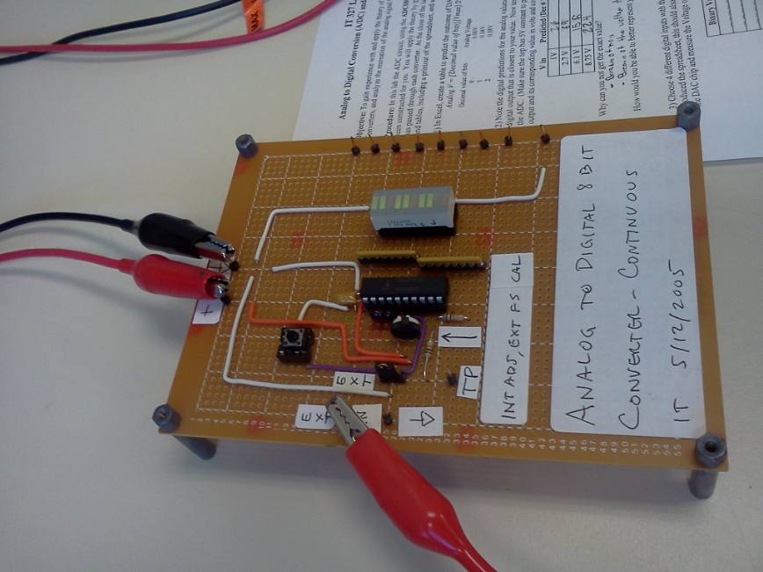

Why can’t you get the exact value?

Because of Spectrum the voltage is not turning every single bit on. Also noise is a factor as well.

How would you be able to better represent your exact value digitally?

Increase the divisions of bits. If you get more bits the digital representation will be more accurate.

## Step 3:

Select 4 different digital inputs with the 8 bit switch and predict the analog output before you do it. Comparing to the spreadsheet developed previously. Test your predictions with the DAC. (Hook up the ±15 to the DAC chip and measure the Voltage output with a DMM).

|  |  |  |  |  |  |
| --- | --- | --- | --- | --- | --- |
| Predicted | | | Actual | | % Voltage difference |
| Binary Value | Dec # | V out | Dec # | V out |  |
| 00110010 | 50 | 1.95 | 49 | 1.91 | 2.05 |
| 01100100 | 100 | 3.9 | 152 | 5.94 | 34.34 |
| 10010110 | 150 | 5.86 | 147 | 5.75 | 1.88 |
| 11001000 | 200 | 7.81 | 197 | 7.68 | 1.66 |

Was it easier to predict the outcome this time?

No, it wasn’t.

What does this say about the endurance of digital information compared to analog?

Analog are more precise, more accurate.

## Step 4:

Feed a sine wave using the function generator into the ADC. Connect the resulting bits into the input bits on the DAC. Use a DC offset so your sine wave will not be clipped by the A/D. Observe at the reconstructed waveform from the D/A to see how it compares to the original wave. Do this for the following frequencies: 100 Hz, 500 Hz, and 2 KHz.

Screenshot below is to demonstrate the right settings for part of the lab, you should get similar lab settings having both boards (DAC and ADC) connecting the pins (bits) to each other:

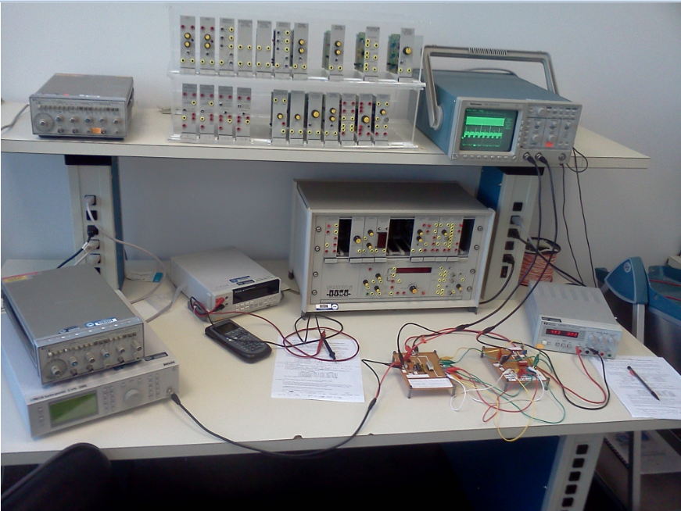

The following screenshot is setting the frequency to 100 Hz.

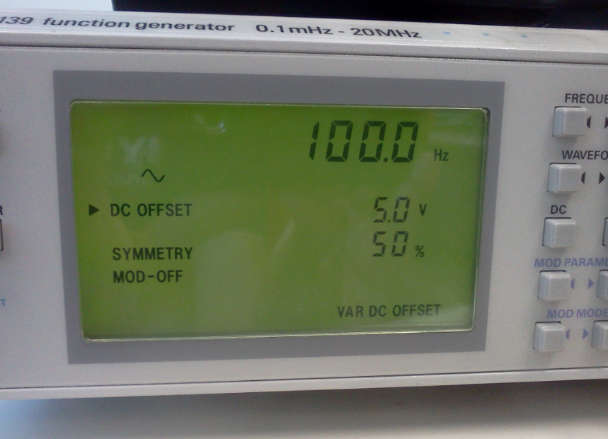

The below screenshot is the resulting sine wave being reconstructed at 100 Hz.

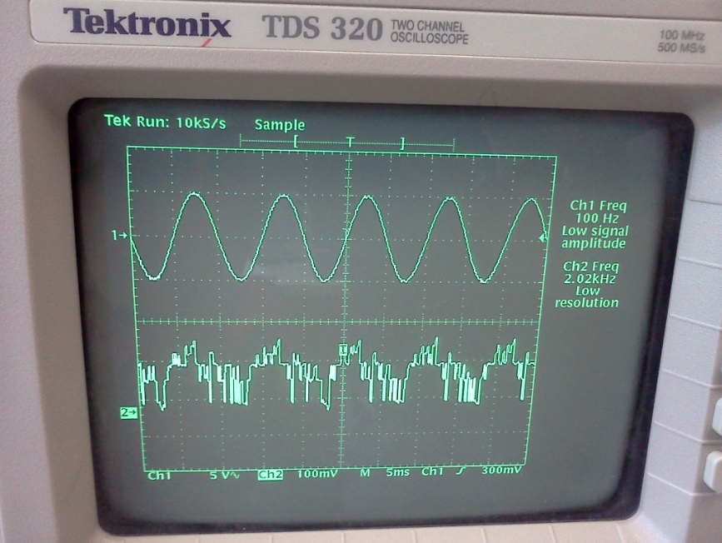

The following screenshot is setting the frequency to 500 Hz.

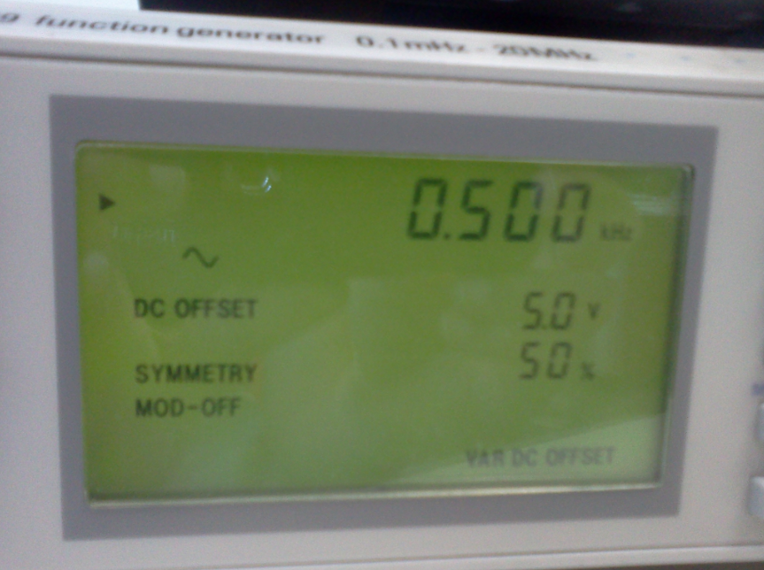

The below screenshot is the resulting sine wave being reconstructed at 500 Hz.

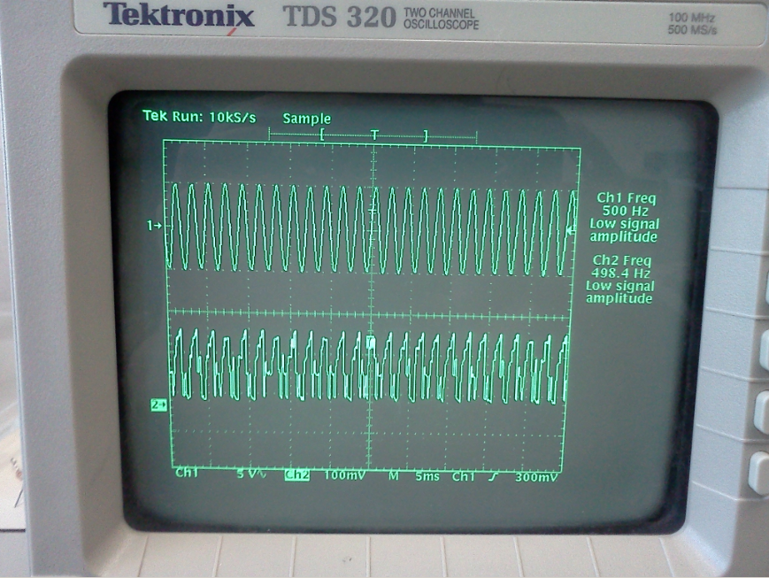

The following screenshot is setting the frequency to 2000 KHz.

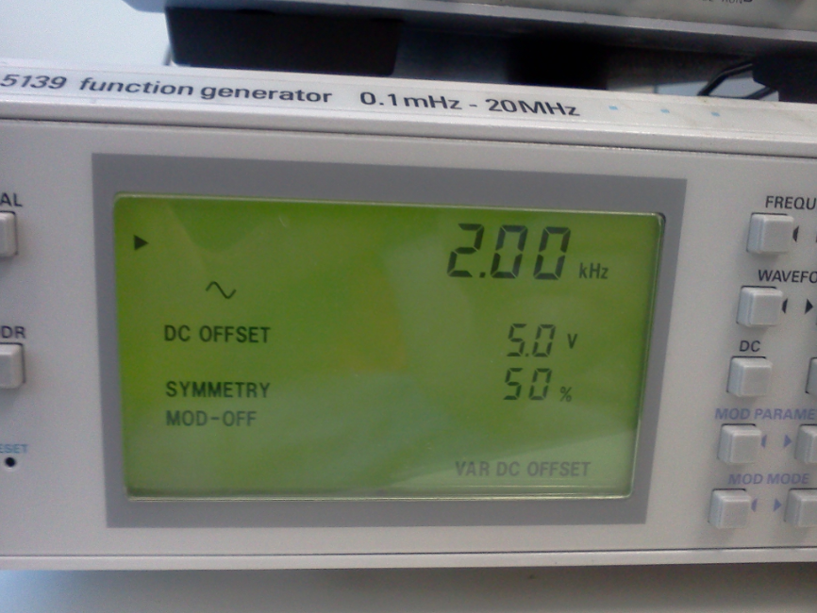

The below screenshot is the resulting sine wave being reconstructed at 2000 KHz.

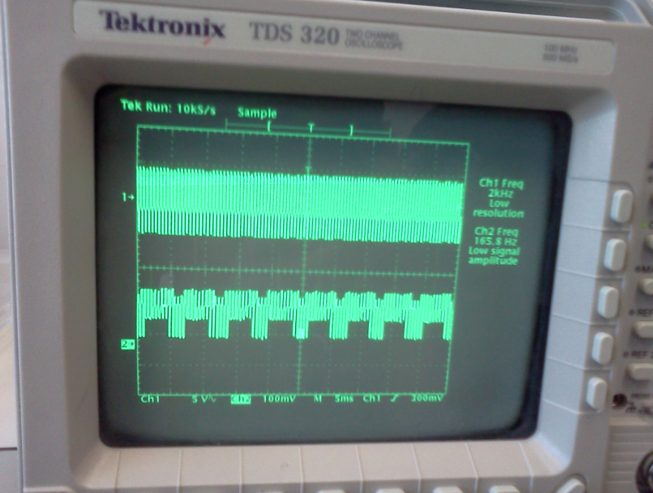

Observing all three frequencies reconstructed waveform from digital to analog I see that at 100 and 500 Hz the digital to analog signal is pretty close from the actual sine wave, but as the frequency became higher such as 2 KHz the digital to analog signal became a bit far off from the original sine wave and that is due to that more harmonics are allowed to go through and that causes more noise.

## Questions:

What determines how accurate an A/D converter will represent the original signal?

What determines how accurate an A/D converter will represent the original signal is the division size and the number of bits.

Why was the signal distorted at the higher frequency on Procedure 4?

More harmonics are allowed to go through and that causes more noise. To solve it put a low pass filter.

# Equipment Used

* Function generator: Fluke And Philips The T&M Alliance model: PM5139.
* Oscilloscope: Tektronix TDS 320
* ADC0804: Analog to Digital 8 bit converter – Continuous.
* DAC0808: Digital to Analog 8 bit converter – Continuous 0-10V Output.

# Report

Comparing my results against expected was very close from each other. It was good and important to first analyze the expected results and then measure the using the boards to conclude the voltage that goes through them as well as how a signal can be rebuilt from digital to analog.

It was also important to me to see the steps on how to actually convert these signals using the 2 boards provided for this lab, connecting them to each other as for converting the right bits accordingly was very informative.

The lab was educational and it was important to me to see the relationships of converting signals from digital to analog and from analog to digital, I feel confident to replicate this lab and know the reasons for each step.

As I worked through the different steps I have noticed how lower frequency such as 100 Hz and 500 Hz from digital to analog are very close from the original signal, but once the a higher frequency is applied to the signal the constructing of the digital to analog signal is far off from the original signal, that is due to that more harmonics are able to get through the signal and therefore causing more noise on the rebuilt signal.

# Conclusion

This lab has reinforced me the importance of converting from digital to analog and from analog to digital. It was also important to see the relation of Analog formula they co-relate very closely although not perfectly to it real voltage as expected.

As I researched more about the signal conversion from digital to analog I have found that this is very used these days, devices such as generation of audio signals from digital information in music players. Digital video signals are converted to analog in TVs and cell phones to display colors and shades. Digital-to-analog conversion can degrade a signal, so conversion details are normally chosen so that the errors are negligible.

Also the conversion from analog to digital is also well used these days as in the case of music production is done on computers, when an analog recording is used, an ADC is needed to create the Pulse-code modulation, which is a method used to digitally represent sampled analog signals data stream that goes onto a compact disc or digital music file.

This lab was very important into knowing such conversions from analog to digital or digital to analog, how the conversion is done and how a signal can be constructed from way format such as digital to another such as analog.

**Name: Lehi Alcantara**

**Completion Date: 10/25/2011**